**E-Vehicle Wireless Charging Station**

*Kiran Prakash Jagtap1, Shashikant Kailas Shinde2, Atharv Shridhar Bakare3, Shivkumar Vijaykumar Sapkal4*

*1Associate professor, Computer Science and Engineering, Dr. Babasaheb Ambedkar Technological University, Lonere, Maharashtra, India.*

*2,3,4UG, Computer Science and Engineering, Dr. Babasaheb Ambedkar Technological University, Lonere, Maharashtra, India.*

***Emails:***[*kpj_cse@yes.edu.in*](mailto:r.venkatakrishna@lords.ac.in)*1,* [*jshashinde@gmail.com*](mailto:roshanshashaik@gmail.com)*2,* [*atharvbakare322@gmail.com*](mailto:bpraneeth123@gmail.com)*3,* [*shivkumarsapkal1234@gmail.com*](mailto:safoorayasmeen17@gmail.com)*4*

**Abstract**

*The growing adoption of electric vehicles (EVs) necessitates innovative and efficient charging solutions to support their widespread use. This project introduces a wireless EV charging station leveraging Tesla coil technology, Internet of Things (IoT) integration, and advanced software for real-time monitoring and management. The system eliminates the need for physical connectors, ensuring convenience, reduced maintenance, and enhanced safety. By utilizing IoT- enabled sensors, the station provides detailed data on charging status and power consumption while also supporting predictive maintenance and secure payment systems. This approach aligns with sustainability goals, offering an eco-friendly and technologically advanced solution to meet the demands of modern EV users. Future enhancements include improving energy transfer efficiency, expanding compatibility across diverse EV models, and integrating with smart city infrastructure for seamless urban mobility.*

***Keywords:*** *Wireless, IoT, Sustainability, Automation*

1. **Introduction**

The global transition toward sustainable energy has positioned electric vehicles (EVs) at the forefront of contemporary transportation solutions. Once considered a vision of the future, EVs have now become a practical reality, embraced by consumers, supported by governments, and integrated into various industries due to their environmental advantages. Despite this growing acceptance, a critical challenge persists: the need for charging solutions that are not only efficient and dependable but also user-friendly. Traditional plug-in charging systems, though effective, present several drawbacks, including connector degradation, the inconvenience of manual handling, and occasional safety risks. Overcoming these limitations calls for innovative advancements capable of transforming the EV charging landscape. To address this need, the E-Vehicle Wireless Charging Station introduces a novel integration of Tesla coil technology, Internet of Things (IoT) features, and intelligent software systems. By utilizing a Tesla coil, the system facilitates wireless power transfer via high-frequency electromagnetic fields, thereby eliminating the necessity for physical connectors. This wireless approach enhances user convenience, minimizes wear on hardware components, and improves overall operational safety. The E-Vehicle Wireless Charging Station offers an innovative solution by combining Tesla coil-based wireless power transfer with Internet of Things (IoT) integration and intelligent software systems. This setup leverages high-frequency electromagnetic fields generated through Tesla coils to facilitate wireless charging, effectively removing the need for physical connectors. This not only simplifies the user experience but also reduces mechanical wear and enhances operational safety [1].

1. **Method**

The technology of wireless charging is one that is growing quickly and has attracted a lot of attention lately. Monitoring the charging process to guarantee effective and secure charging is one of the difficulties with wireless charging. The ESP32 module is a well-liked option for tracking wireless charging stations due to its low power consumption and wireless capabilities. We go over some of the most current research on ESP32-based wireless charging station monitoring in this overview of the literature. Research indicates that using the ESP32 module as a foundation for monitoring wireless charging stations is dependable and effective [2-4]. To guarantee effective and secure charging, The user can receive feedback, collect data, and monitor in real time with the ESP32 module. Further research is necessary in order to optimize the functionality and performance of ESP32-based wireless charging stations and explore the variety of potential applications for them.

At the core of this setup lies the ESP32 Microcontroller, serving as the central control unit. This controller manages diverse operations such as communication with the app control interface, coordination of the charging process, interaction with various sensors anddetectors, and implementation of power-saving measures. The charging system comprises Dual Spot Charging, facilitating the simultaneous wireless charging of two electric vehicles. This process is enabled through Inductive Power Coils, ensuring efficient energy transfer. The MOSFET (IRZ44N) regulates and controls the power flow, ensuring the safety and efficiency of the charging process. Interfacing with the app control interface, users can seamlessly manage and monitor the charging process via a mobile application. Commands initiated through the app interface are processed by the ESP32 controller, enabling actions like initiating or ceasing the charging process. Sensors and detectors integrated into the system include an IR Sensor responsible for vehicle detection and positioning, enabling automated charging when a vehicle is parked over the charging spot. The Auto Detection System identifies electric vehicles and triggers the initiation of the charging process automatically upon detection. Additionally, the system incorporates voltage regulation using a Voltage Regulator (7805) for stable voltage supply and energy-saving components to optimize power consumption. A Storage Battery (Lead Acid) acts as a backup power source, ensuring uninterrupted service in case of power failure or emergencies. Display functionalities are facilitated by a 16x2 LCD Display, providing real-time visual feedback on the charging status. Together, these components and their collaborative functioning, orchestrated by the ESP32 controller, create a robust and efficient wireless charging infrastructure for electric vehicles, focusing on user convenience, safety, and energy efficiency.

* 1. **Figure**

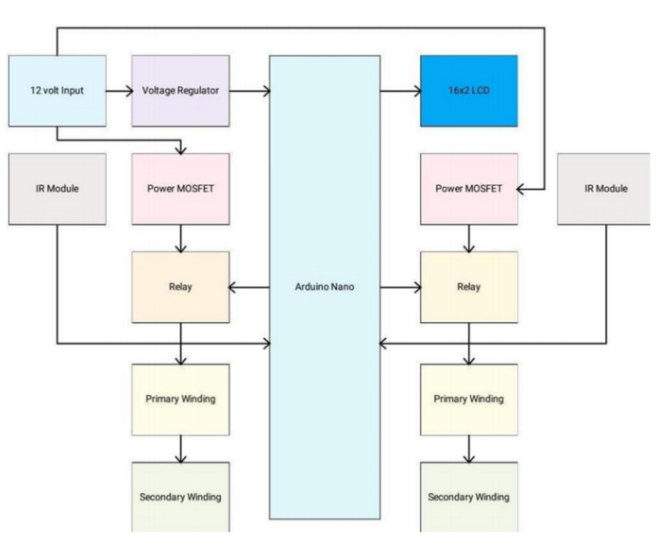

**Figure 1 Block Diagram**

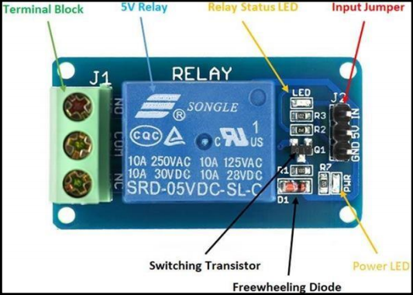

**Figure 2 Relay Module**

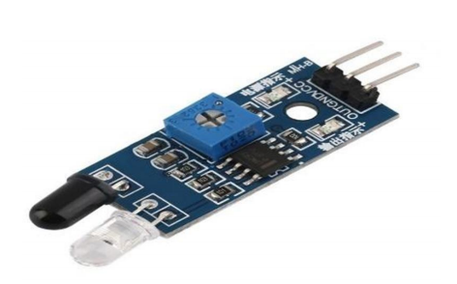

**Figure 3 IR Sensor**

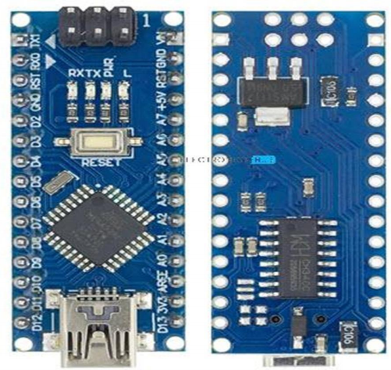

**Figure 4 Arduino Nano**

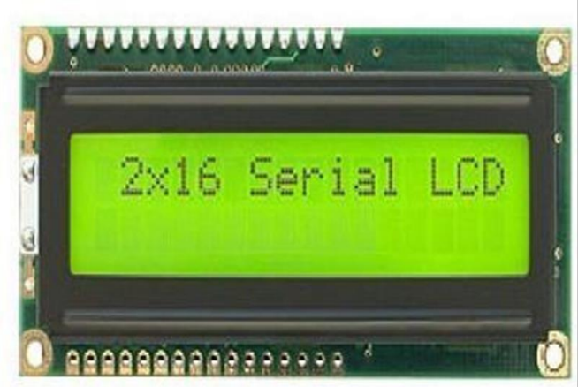

**Figure 5 LCD Display**

1. **Results and Discussion** 
   1. **Results**

The prototype model using a Tesla coil and ESP32 was successfully tested for wireless charging of a small robot. The Tesla coil enabled short-distance power transfer, and the ESP32 efficiently controlled system operations, including wireless monitoring and sensor-based automation. The mobile application allowed real-time control of charging functions, and the IR sensor reliably detected the robot's position to activate charging automatically. In case of power failure, the lead-acid battery provided backup power, ensuring uninterrupted operation. The LCD display clearly showed the system's status during testing. Overall, the setup demonstrated that wireless charging using Tesla coil technology is practical and effective for small-scale models, with good accuracy and system stability, shown in Figure 1 to 5.

* 1. **Discussion**

The experimental prototype using a Tesla coil for wireless charging and an ESP32 for system control demonstrated promising results for small-scale EV applications. The ESP32 module proved effective in managing real-time operations, including wireless communication, vehicle detection, and power control.

The Tesla coil enabled efficient short-range energy transfer, though the effective distance was limited, indicating a need for better coil design or power amplification for larger-scale use. The IR sensor accurately triggered the charging process upon detecting the robot, confirming the reliability of the automated system [5-7].

**Conclusion**

The **E-Vehicle Wireless Charging Station** utilizing **Tesla coil technology and IoT** represents a forward-thinking and efficient approach to charging electric vehicles. By removing the dependency on physical connectors, the system improves user convenience and minimizes maintenance needs. The incorporation of IoT enables real-time data monitoring and intelligent system management. Additionally, the software enhances the overall user experience by offering features like energy usage tracking. With possibilities for future upgrades such as mobile application support and improved charging performance, this solution shows strong potential in promoting sustainable and smart urban transportation.

**Acknowledgements**

We would like to express our sincere gratitude to all the individuals who played a crucial role in the successful completion of this mini project. Their guidance, support, and encouragement have been instrumental throughout the project journey. We are deeply thankful to our project guide, **Prof. Kiran Jagtap**, for his constant guidance, valuable insights, and unwavering support. His mentor-ship has been essential in shaping the direction and execution of this project. We gratefully acknowledge that this work did not receive any specific financial support from public, commercial, or not-for-profit funding agencies.

**References**

1. [Gouri Abhay Kulkarni](https://ieeexplore.ieee.org/author/37089284867);[Radhika D Joshi](https://ieeexplore.ieee.org/author/37085836777) [2021 10th International Conference on Internet of Everything, Microwave Engineering,](https://ieeexplore.ieee.org/xpl/conhome/9688563/proceeding) [Communication and Networks (IEMECON)](https://ieeexplore.ieee.org/xpl/conhome/9688563/proceeding)
2. Sujitha. S; Vinoth Kumar. K; Vinodha. K; Josh F T; Venkatesh. B 2021 IEEE International Conference on Mobile Networks and Wireless Communications (ICMNWC)
3. R. Kavin; D. Arvind; S. Dhanush; D. Ajay; K. Karpaganathan 2022 7th International Conference on Communication and Electronics Systems (ICCES)
4. Naresh Kumar K; P. Badrinath; S. Vickraman; G. Satheesan 2022 International Interdisciplinary Humanitarian Conference for Sustainability (IIHC)
5. Dimitar Arnaudov; Bozhidar Tashkov; Ivailo Hristov; Ivan Yutidzhiyan; Krasimir Kishkin 2021 29th National Conference with International Participation (TELECOM)
6. Md Mujahid Irfan; Sanjana Gajula; Sainath Busigampala; Ashritha Gulla; Ajay Nayak Gugulothu; Anirudh Davera 2023 4th International Conference on Communication, Computing and Industry 6.0 (C216)
7. [Dhanveer Mehar](https://ieeexplore.ieee.org/author/37089765148);[Rishi Kumar Singh](https://ieeexplore.ieee.org/author/37088523452);[Ankur Kumar Gupta](https://ieeexplore.ieee.org/author/37086516283) [2023 IEEE Renewable Energy and Sustainable E-Mobility Conference (RESEM)](https://ieeexplore.ieee.org/xpl/conhome/10235975/proceeding)