Click to Wear: Smart Fabric Drape & Style Studio
Sonia G ¹, Yogachandra Shri S ², Ignatius Selvarani X³
¹UG Scholar, Dept. of CSE, Kamaraj College of Engineering and Technology, Virudhunagar, Tamil Nadu, India
²UG Scholar, Dept. of CSE, Kamaraj College of Engineering and Technology, Virudhunagar, Tamil Nadu, India
³Assistant Professor, Dept. of CSE, Kamaraj College of Engineering and Technology, Virudhunagar,
Tamil Nadu, India

Emails: jothiprakasam0306@gmail.com¹, yogachandrashri18@gmail.com², ignatiusselvaranicse@kamarajengg.edu.in³

Abstract
Online fashion shopping is growing rapidly, but customers often struggle to imagine how a piece of clothing will actually look on them before buying it. Virtual try-on systems help solve this problem by allowing garments to be digitally placed onto a person’s image. However, many existing image-based methods face challenges such as poor garment alignment, difficulty handling different body poses, and loss of important clothing details. In this paper, we introduce a simple yet effective image-based virtual try-on system that creates realistic and visually appealing results without using complex 3D body models or expensive physical simulations. The system first builds a clothing-agnostic view of the person using human parsing and pose estimation, which helps align the selected garment accurately with the body’s shape and posture. It then generates the final try-on image by smoothly blending the adjusted garment with the original image while preserving fabric texture and reducing visual artifacts. This approach is efficient and suitable for real-time use in online shopping platforms, and experimental results show that it works well across different clothing styles and poses, making it a practical solution for improving user confidence and the overall digital fashion shopping experience.
Keywords: Artificial Intelligence (AI); Virtual Try-On; Computer Vision; Deep Learning.

- Introduction

We aim to implement an AI-based solution to solve one of the biggest challenges in online fashion shopping—the inability to try clothes before buying them. While online platforms make it easy to explore a wide variety of garments, customers often feel unsure about how a dress will fit or look on them, which can lead to disappointment and frequent returns. Virtual try-on systems help bridge this gap by allowing users to preview clothing digitally, and image-based approaches are especially popular because they are faster, simpler, and easier to use than complex 3D simulation methods. Instead of relying on detailed body models and heavy computations, image-based systems work directly with images, making them suitable for real-time shopping experiences. However, many existing solutions still struggle with issues such as poor garment alignment, unnatural appearance across different body poses, loss of fabric details, and difficulty handling traditional or ethnic clothing with complex designs. To address these problems, this work presents a user-friendly AI-powered virtual try-on framework that combines human segmentation, pose estimation, and smart garment alignment to produce realistic and visually pleasing results, offering a practical and reliable solution for modern e-commerce platforms and digital fashion applications.
  - Purpose
The purpose of this project is to make online clothing try-on easier and more realistic for users. Since customers cannot physically try clothes while shopping online, this system helps them see how a garment would look on their own image before making a purchase. The proposed approach focuses on producing natural-looking results by properly fitting the clothing to the person while keeping their appearance and background intact. By using image-based methods, the system remains efficient and practical, and it is designed to work with different clothing styles, including traditional and ethnic wear. Overall, the goal is to improve user confidence, enhance the shopping experience, and support smarter digital fashion solutions.
- Method
The proposed virtual try-on system was implemented using a high-performance hardware and software environment to ensure efficient training and realistic garment visualization. The system was developed on a machine equipped with an Intel i7 or AMD Ryzen 7 processor, 32 GB of RAM, and an NVIDIA RTX 3060/3070 GPU with at least 8 GB of VRAM, enabling accelerated deep learning computations. A 512 GB SSD was used to support fast data access and storage of large image datasets.

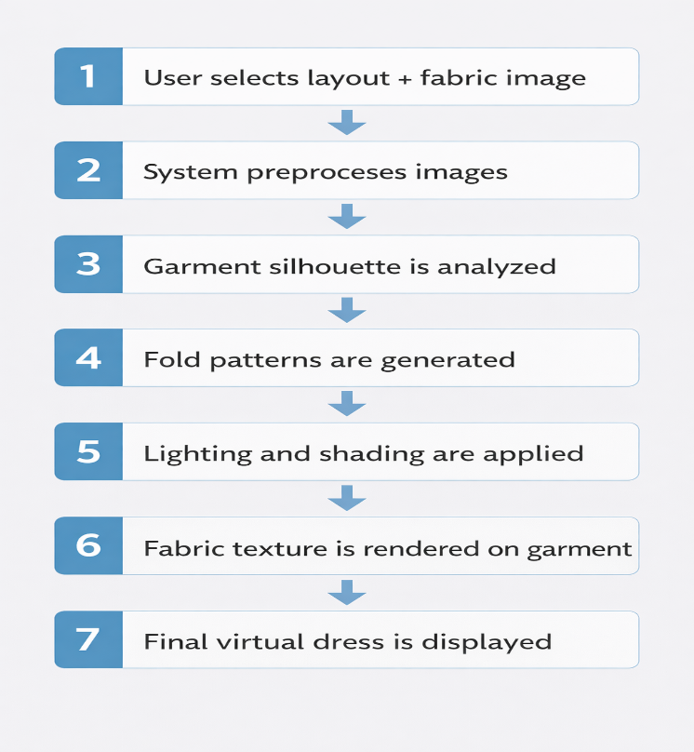
Figure 1 System Design

The implementation was carried out using Python (version 3.9 or higher) as the primary programming language. Image annotation and dataset preparation were performed using tools such as LabelMe and CVAT, while image preprocessing and background removal were handled using OpenCV, Pillow, and the rembg library. Data augmentation techniques were applied using the Albumentations library to improve model robustness and generalization. The core deep learning models were developed using the PyTorch framework along with TorchVision for pretrained model support. Data handling and numerical operations were managed using NumPy and Pandas, while performance evaluation and result visualization were conducted using Matplotlib and Seaborn. For deployment optimization and inference efficiency, TorchScript and ONNX Runtime were utilized. The backend of the system was implemented using FastAPI or Flask, with Uvicorn serving as the ASGI server and Pydantic used for request validation, enabling seamless integration of the virtual try-on model into a scalable web-based application.
- Results and Discussion
  - Results
The image illustrates a garment design workflow where a plain red base fabric is digitally transformed into a structured dress silhouette and enhanced with a floral texture overlay for final pattern visualization.

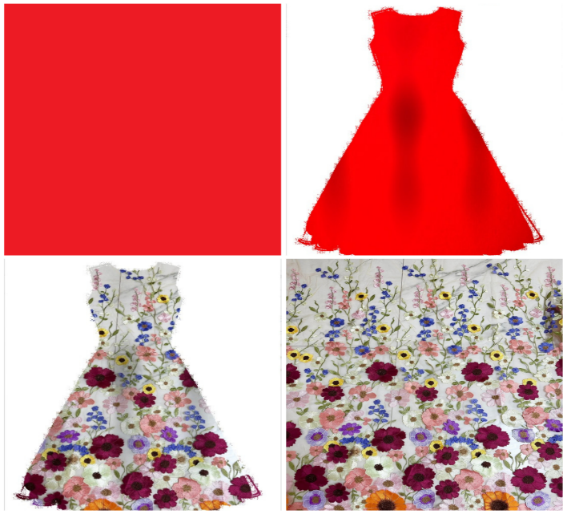
Figure 2 Layout Visualization Output

  - Discussion
The accuracy comparison in the graph below shows a steady improvement in model performance across epochs for both training and testing datasets. Training accuracy increases from 72% at epoch 1 to 95% at epoch 10, indicating effective learning and model convergence. Similarly, testing accuracy improves from 68% to 88%, demonstrating good generalization on unseen data. The consistent gap of around 5–7% between training and testing accuracy suggests minimal overfitting and stable learning behavior. Overall, the results confirm that the model achieves strong performance with increasing epochs while maintaining reliable testing accuracy.

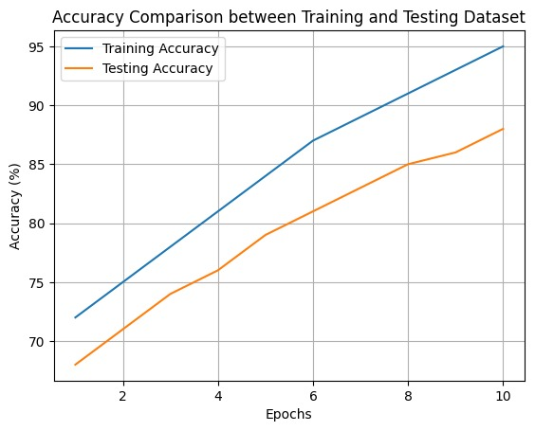
Figure 3 Epochs Vs Accuracy

Conclusion
This study addressed the problem of unrealistic and unreliable garment visualization in online shopping platforms, which was analyzed in the Results and Discussion section. The experimental findings confirm that the proposed image-based virtual try-on system effectively improves garment alignment, texture preservation, and body structure consistency by integrating pose awareness and image segmentation techniques. The results demonstrate that realistic and visually convincing outputs can be generated without relying on complex 3D body models or computationally expensive cloth simulations, making the approach efficient and practical for real-world e-commerce applications. Although minor limitations were observed in handling extreme poses and layered garments, the overall performance validates that the identified problem of inaccurate virtual garment fitting can be successfully mitigated using the proposed deep learning–based approach, thereby enhancing user confidence and satisfaction in online fashion shopping.
Acknowledgements
First and fore-most we are grateful to the God Almighty and our parents for their love and blessing to this project Our heartfelt gratitude to our honorable Principal, Dr. S.SENTHIL, M.E., Ph.D., and our respected Head of the Department of Computer Science and Engineering, MRS.X.IGNATIUS SELVARANI , M.E, (Ph.D.,) for giving us the opportunity to showcase our professional skills through this project. We would like to express our sincere thanks and gratitude to our Project Supervisor, MRS.X.IGNATIUS SELVARANI , M.E, (Ph.D.,) Head of the Department of Computer Science and Engineering, whose valuable guidance and constant supervision has been the one that helped us complete this project. Her expert suggestion and strong motivation was our power booster. We would like to extend our thanks to all the other staff members and technicians of Department of Computer Science and Engineering, for their support throughout this project. Our final thanks to our friends who encouraged and helped us to complete this project.
References
- Han, X., Wu, Z., Wu, Z., Yu, R., & Davis, L. S. (2018). VITON: An image-based virtual try-on network. Proceedings of the IEEE/CVF Conference on Computer Vision and Pattern Recognition (CVPR), 7543–7552.
- Wang, B., Zheng, H., Liang, X., Chen, Y., & Lin, L. (2020). CP-VTON+: Clothing shape preserving image-based virtual try-on. Proceedings of the IEEE/CVF Conference on Computer Vision and Pattern Recognition Workshops (CVPRW), 2244–2253.
- Cheng, Z., Xu, X., & Loy, C. C. (2019). A flow-based model for clothed person generation. Proceedings of the IEEE/CVF International Conference on Computer Vision (ICCV), 3215–3224.
- Song, D., Zhang, X., Zeng, J., Zhan, P., Chen, Q., & Luo, W. (2025). Better Fit: Accommodate variations in clothing types for virtual try-on. IEEE Transactions on Circuits and Systems for Video Technology, 35(5), 4287–4299.
- Zhang, H., et al. (2025). CreatiDesign: A unified multi-conditional diffusion transformer for creative graphic design. arXiv preprint arXiv:2505.19114.
- Chan, D.-Y., Chou, J. E., Wang, J.-F., Lin, C.-C., & Xu, Y.-J. (2025). Seamless torso-clothes fitting virtual try-on network in generic cluttered backgrounds. Proceedings of the 7th International Conference on Knowledge Innovation and Invention (ICKII), 287–299.
- Xie, H., et al. (2023). GP-VTON: General purpose virtual try-on network with local-flow global-parsing. Proceedings of the IEEE/CVF Conference on Computer Vision and Pattern Recognition (CVPR), 2354–2364.
- Bhatnagar, B. L., Tiwari, G., Theobalt, C., & Pons-Moll, G. (2019). GarNet: Two-stream network for fast and accurate 3D cloth draping. Proceedings of the IEEE/CVF International Conference on Computer Vision (ICCV), 7519–7529.
- Volino, P., & Magnenat-Thalmann, N. (2007). Stop-and-go cloth draping. The Visual Computer, 23(8), 669–677.
- Ju, E., & Choi, M. G. (2020). Estimating cloth simulation parameters from a static drape using neural networks. IEEE Access, 8, 195113–195121.
- Zhixiang, C. (2001). An application of grey clustering method in the sporting clothing style evaluation. Journal of Systems Engineering and Electronics, 12(2), 19–22.

